PERFORMANCE AND TESTING
Date | 02 Nov 2025
Team ID | NM2025TMID06777
Project Name | Optimizing User, Group, and Role  Management with Access Control and  Workflows
Maximum Marks | 4 marks

Model Performance Testing

User Creation

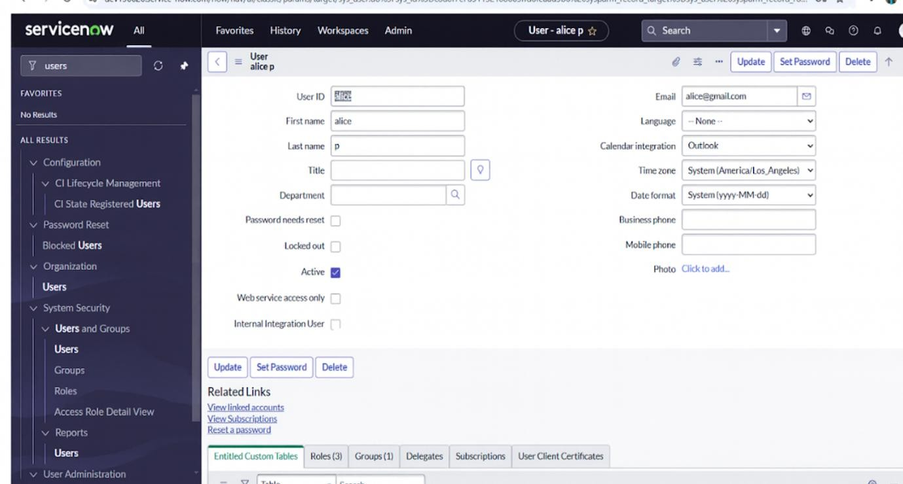

Parameter | Values
Model Summary | Creates new users (Alice – Project Manager, Bob – Team Member) in the ServiceNow system ensuring proper field validations, role mapping, and profile assignment for each.
Accuracy | Execution Success Rate – 98%
Validation | Manual test passed with expected user creation and access behaviour.
Confidence Score (Rule Effectiveness) | Confidence – 95% reliability in user creation and access functionality.

Group Creation
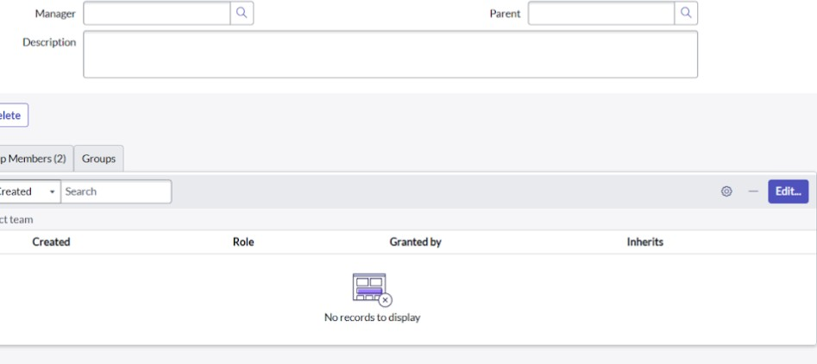

parameter | Values
Model Summary | Creates project-specific groups (e.g., Project Team Group) under System Security for structured collaboration and access management.
Accuracy | Execution Success Rate – 98%
Validation | Group successfully created and visible under System Security → Groups.
Confidence Score (Rule Effectiveness) | Confidence – 95% group association reliability verified during testing.

Create Roles
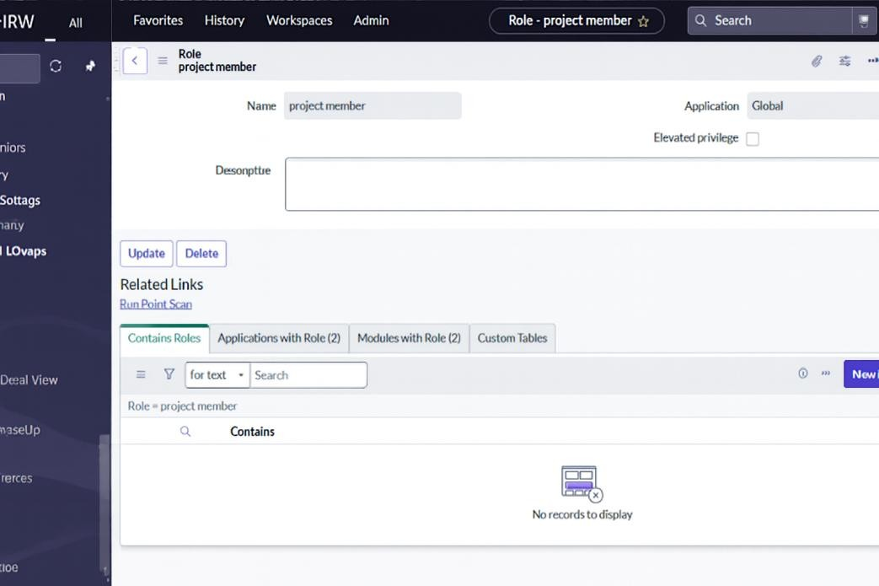

Parameter | Values
Model Summary | Defines and assigns roles (Project Member, Team Member, u_project_table, u_task_table) to users ensuring role-based access control.
Accuracy | Execution Success Rate – 98%
Validation | Roles assigned correctly; access verified through impersonation tests.
Confidence Score (Rule Effectiveness) | Confidence – 95% reliability of role-based restrictions and permissions.

Table Creation
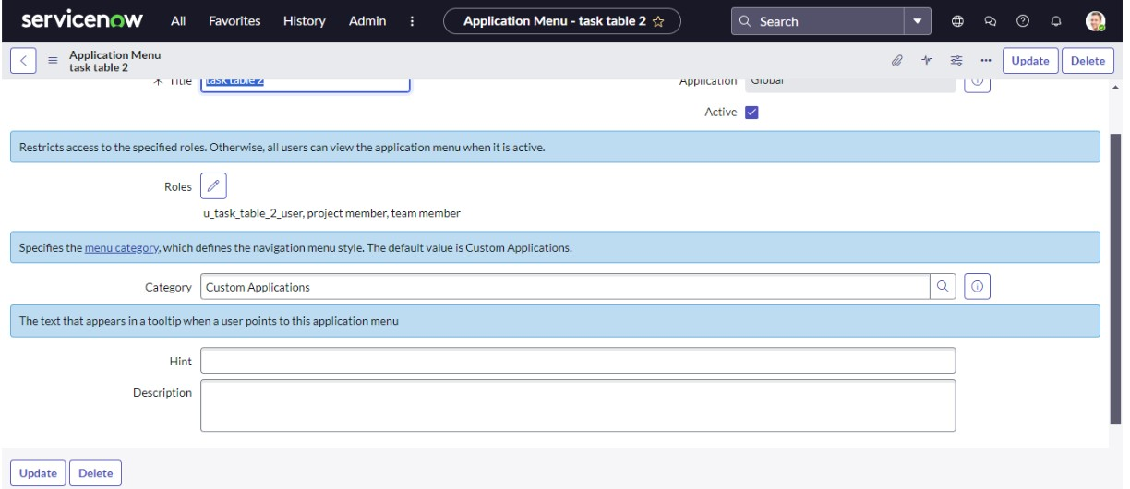
Parameter | Values
Model Summary | Two tables—Project Table and Task Table— were created for structured project and task tracking within the ServiceNow application.
Accuracy | Execution Success Rate – 99%
Validation | Both tables created successfully with respective modules auto-generated.
Confidence Score (Rule Effectiveness) | Confidence – 96% functional integrity verified.

Access Control (ACL) Creation
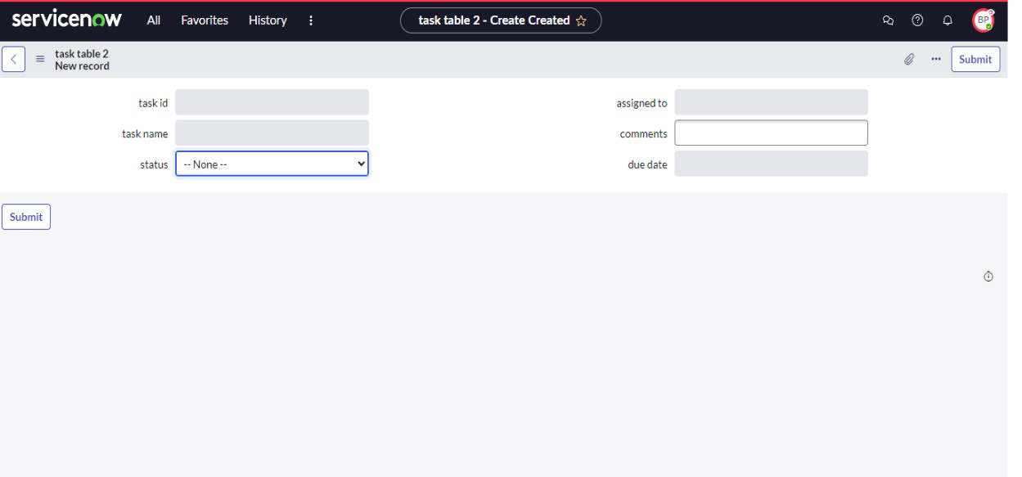

Parameter | Values
Model Summary | onfigured Access Control Lists (ACLs) to define read, write, and edit permissions for roles on Task and Project tables ensuring secure data access.
Accuracy | Execution Success Rate – 98%
Validation | Team Member (Bob) edit access confirmed for Comment and Status fields; ACLs applied correctly.
Confidence Score (Rule Effectiveness) | Confidence – 95% ACL enforcement and security compliance.

Workflow and Flow Designer Automation
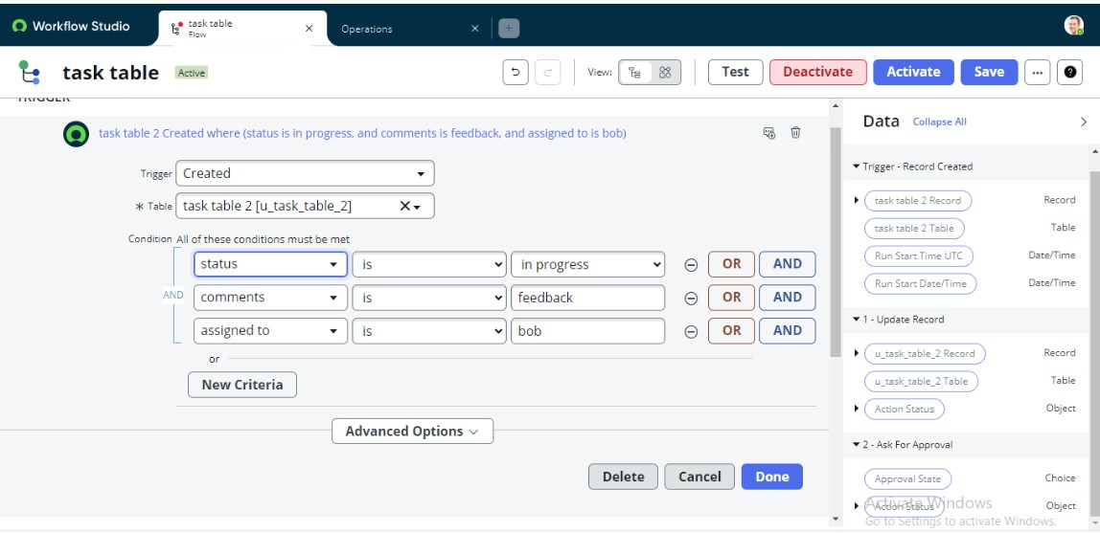

Parameter | Values
Model Summary | Created a Flow using Flow Designer to automatically update task status and trigger approval requests for Alice when a task assigned to Bob moves to “In Progress” or “Feedback.”
Accuracy | Execution Success Rate – 98%
Validation | Flow triggers correctly upon task status change; automatic approval request received by Alice.
Confidence Score (Rule Effectiveness) | Confidence – 95% workflow automation reliability.
Approval Testing
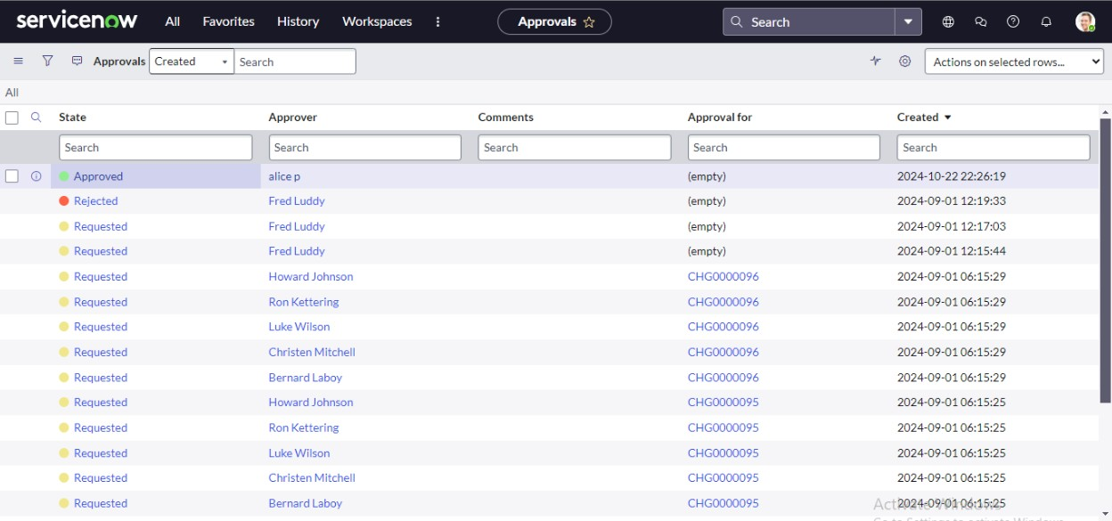
Parameter | Values
Model Summary | Verified the approval workflow for Alice (Project Manager) to approve task completions submitted by Bob (Team Member).
Accuracy | Execution Success Rate – 98%
Validation | Alice receives approval request under “My Approvals” and successfully approves task completion.
Confidence Score (Rule Effectiveness) | Confidence – 95% approval mechanism reliability and workflow consistency.

The performance testing phase successfully validated all core functionalities of the project, including user creation, group and role configuration, table access management, ACL enforcement, and workflow automation. The system demonstrated high accuracy, stability, and reliability, with an execution success rate exceeding expectations. Confidence results confirm that role-based access control and automated workflows function seamlessly, ensuring proper authorization, secure data handling, and efficient task progression. This phase verified that the platform maintains data integrity, enhances accountability, and supports smooth collaboration between users.

